Forest H.

Weekly report 3

Academind Restful api

REST as in representational state transfer, is an alternative to a traditional webpage. If there is a case where html is not needed, like a mobile app client, situations were just data is wanted not html, SPA is another example as it stores and fetches data but never renders and html page. A RESTful server still takes requests and handle responses with urls. All it does is exchange data, often in JSON format but can also be FormData, URLEncoded, and xml. Want to develop one with products with get and post, product ids with get patch and delete, orders with get and post, order ids with get and delete. Most of this weeks work has been done on research and project planning rather than coding. But a simple test was developed.

Udacity

Internet routing, autonomous systems are independently operated networks that connect via internet routing. Intradomain routing is traffic within a system and inter is between Ass. A topology consists of nodes and edges, this is contained within an intra AS. One such network is the Abeline network which consists of nodes(aka pops) spanning the country. Distance vector routing are based on the bellman-ford algorithm dx(y) = minv(c(x,v))+dv(y)).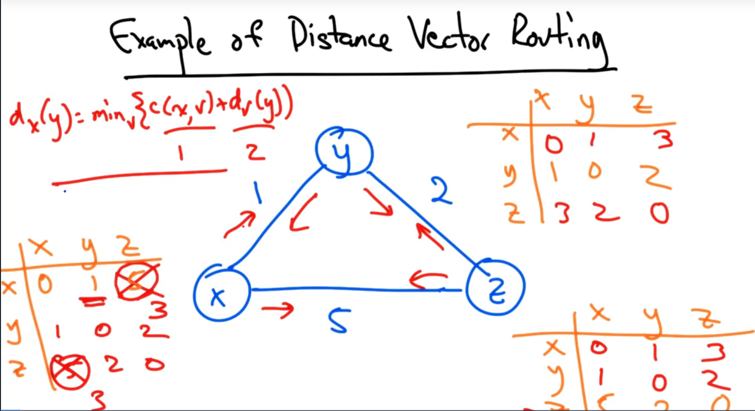

Another exampleI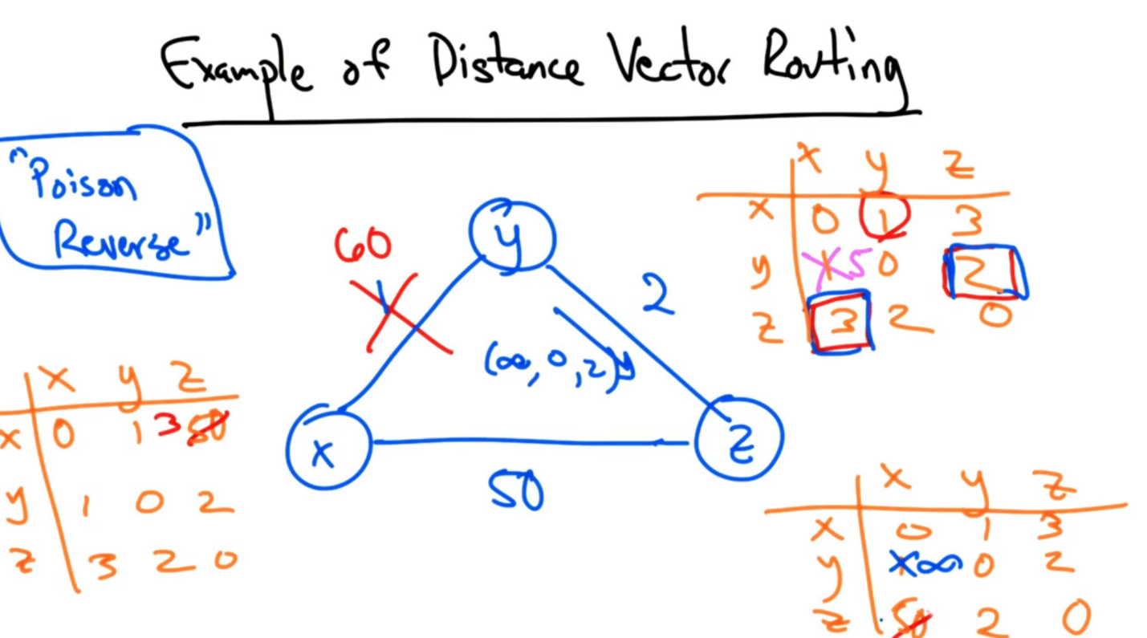

In link state routing a network map has each node perform SPF(shortest path computation), checks neighbors and computes. BGP border gateway protocol is used to route between AS for interdomain routing. Local preferences can be set to control outbound traffic, this is useful when configuring primary and backup routes. Sometime an AS will attach a BGP community to effect how a neighboring AS sets local preference, basically just a tag on a route. MED, multiple exit discriminators, areused to selecting allocate network trafifcing to one of the two connected AS, so as to force one to do the heavy lifting. An example being a content provider and transit provider connecting, transit provider doesn’t want the content provider to get free transit through their AS.